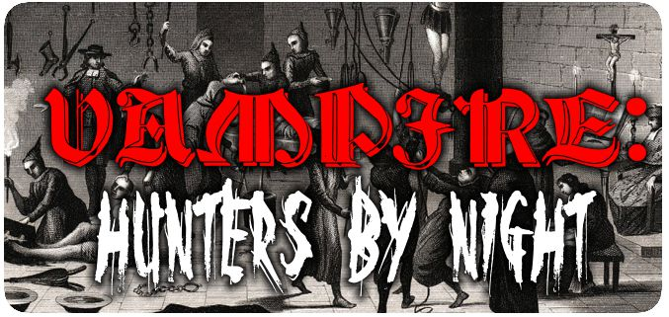 |  |  |  |  |  |  | Starting Info:  Power: Select Religion or Magic  Attributes: 6/4/3; Abilities: 11/7/4; Power 1;  Virtues: 7; Willpower=Courage; Mana=PowerX4;  Humanity=Conscience; Freebies: 21pts (see chart in rules 1); Merits/Flaws: Up to 15pt each
NAME: |  |  | NATURE: |  |  |  |  | POWER:
PLAYER: |  |  | CONCEPT: |  |  |  |  | FAMILY:
CHRONICLE: |  |  | ORDER: |  |  |  |  | HOME:
ATTRIBUTES
PHYSICAL () |  |  | SOCIAL () |  |  |  |  | MENTAL ()
Strength |  |  | Charisma |  |  |  |  | Perception
Dexterity |  |  | Manipulation |  |  |  |  | Intelligence
Stamina |  |  | Appearance |  |  |  |  | Wits
ABILITIES
TALENTS () |  |  | SKILLS () |  |  |  |  | KNOWLEDGES ()
Alertness |  |  | Animal Ken |  |  |  |  | Academics
Athletics |  |  | Archery |  |  |  |  | Hearth Wisdom
Brawl |  |  | Commerce |  |  |  |  | Investigation
Dodge |  |  | Crafts |  |  |  |  | Law
Empathy |  |  | Etiquette |  |  |  |  | Linguistics
Expression |  |  | Melee |  |  |  |  | Medicine
Intimidation |  |  | Performance |  |  |  |  | Occult
Leadership |  |  | Ride |  |  |  |  | Politics
Legerdemain |  |  | Stealth |  |  |  |  | Seneschal
Subterfuge |  |  | Survival |  |  |  |  | Theology
ADVANTAGES
POWERS |  |  | BACKGROUNDS |  |  |  |  | VIRTUES
 |  |  |  |  |  |  |  | Conscience
 |  |  |  |  |  |  |  | Self-Control
 |  |  |  |  |  |  |  | Courage
OTHER TRAITS |  |  | HUMANITY |  |  |  |  | Bruised
 |  |  |  |  |  |  |  | Hurt -1
 |  |  | WILLPOWER |  |  |  |  | Injured -1
 |  |  |  |  |  |  |  | Wounded -2
 |  |  | MANA |  |  |  |  | Mauled -2
 |  |  |  |  |  |  |  | Crippled -5
 |  |  |  |  |  |  |  | Incapacitated
EQUIPMENT |  |  |  |  |  |  |  | NOTES

