Admiral Vance Ellery, Retired
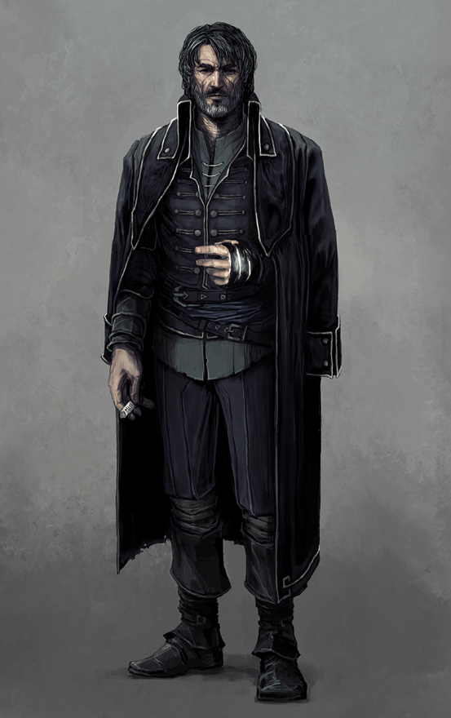
Age: 38 (46)
Height: 5’ 10”
Weight: 205 lb
Hair: Black with tinges of gray, since retiring he wears a full beard.
Eyes: Blue
Distinguishing Marks: A few old scars from wounds (random). Tattoo of a kraken wrapped around a spacecraft (Right Forearm). Tattoo of a pinup girl (Left bicep).
Because people don’t like to read long narratives I’ll start with bullet points and explain them later. I rolled one commendation, a tutor, and a rival:
- One of 5 kids. The other four kids: Army, Marines, Merchant Trader, and another Navy.
- (Tutor) Learned melee blade combat from the base commander’s daughter, wound up marrying and divorcing her.
- (Commendation) Lessened and imminent impact and guided the craft through an asteroid/debris field.
- Second wife was his original rival, subsequently deceased.
- (Rival) Former unit member whom he leapfrogged for promotion. She’s retired too now.
- Retired from the Navy because the higher in rank you go the further you get from the action, which is the reason you go into space.
Vance’s father was from off-world but settled down and raised five children. He’d occasionally regale them with tales of his youth out in the stars. As this has a tendency to do it inspired them to each go off-world themselves. One by one as they came of age they left home. Matthew joined the Army, Gregory the Marines, Lewis became a merchant trader, and Lorraine joined the Navy. And one-by-one they came home. Matthew and Greg were shipped home in caskets. Lewis returned home with a number of injuries and after convalescing took over their parents’ homestead, where he remains today. First to return however had been Lorraine, who died during a training accident at a young age. Vance entered the Navy the day after her funeral despite the objections of his parents who’d lost one child to that branch of service, but relented since they had no choice really.
(NOTE: Vance’s now deceased siblings could easily be his connection to the other military types)
It felt like history was going to repeat itself when during his first tour Vance and his crew were nearly killed in a collision when his craft lost power and momentum took it toward an asteroid belt. He managed to slow the momentum enough to minimize an initial impact and once they survived long enough to get the power back up he piloted the craft out of the belt despite the large amount of shifting debris. He received a commendation.
He picked up his skill with blades from his first wife, Lavinia (tutor), a swordsmanship instructor who was the daughter of a base commander. The marriage was a short-lived affair as when offered a much coveted post he opted to take the job and she did not want to leave. They were married long distance for a while but then divorced as the communications got fewer and fewer.
His second wife, Josephine, was part of a rival unit. Years of the two of them jawing at each other and an undercurrent of sexual tension culminated one night in a drunken affair and several subsequent times where they took shore leave together. He got promoted and moved up the ranks faster than she did, and they never served in the same place together. As they were making arrangements to relocate to the same base, he got word of Josephine’s death when her entire unit died in a deep space firefight that saw their ship decompress. He considers her the love of his life. The tattoo on his left arm is a pinup-style picture of her.
As he made his way up the ranks it meant less and less to him. Each success took him further and further way from the adventure that had made space so interesting to him. Polishing a chair with his ass was not how he intended to go out.
Once at the rank of Admiral, he put in a year and decided there was nothing left in military service for him except dull repetition and lots of paperwork.
He moved home for a short while and found that just as dull as he remembered. He has since decided to reinvent himself.

Personality
At home with both military people and the darker side civilian humanity, it’s really the average people that has trouble interacting with. He feels like he has nothing in common with people living an ordinary existence. Given a choice he can be found at your local hive of scum and villainy.
He does not appreciate being called Admiral. He’ll acknowledge the title, but says essentially “That’s someone else.”
(NOTE: He could easily have met PCs in dive bars or tattoo parlors)

Rival
Cassandra Mox, once a member of his unit. Unhappy with him joining the unit after her and then leapfrogging her to become unit leader when old leader moved on, she’s always held a grudge and went out of her way to compete with him. Vance enjoys a good rivalry. The only thing that kept this from becoming a true adversarial relationship is that he always seemed to do right by the unit. She left the military a few years before he did, mustering out as a colonel and moving on to a cushy gig at a transport company. They’ve crossed paths a few times since his retirement and while they aren’t enemies there’s an undercurrent of competitiveness that he enjoys because it reminds him of his second wife.

