Honours and Awards

The following commendations are given to members of the four primary Imperial services.

Starburst for Extreme Heroism

Description
The medal is a 70mm wide circle made of iridium and is suspended from a 25mm-wide red-and-black cloth ribbon around the neck.
The obverse is inlaid with a pattern of colored gemstones in the form of an Imperial Starburst. The Starburst is in the service color of the recipient's arm of service. The Imperial Interstellar Scout Service is red; the Imperial Navy, yellow; the Imperial Army, black; and the Imperial Marines, maroon.
The reverse is engraved with the words: "With the Gratitude of the (Emperor/Empress) and Imperium, Our Thanks to (recipient's name) of (soldier's homeworld) for (his/her) Actions on (place where the medal was won) on (date of action)".
It is the only award that doesn't come in classes (though it can be granted either as a "straight" SEH or as the more prestigious SEH "with diamonds", (*SEH*)) and is issued uniquely. Every additional receipt is awarded with another medal.
- The holder of an SEH ranks just above the bearer of an MCG, and slightly below a Knight of the Empire in social status before the Emperor. ^{[1]}
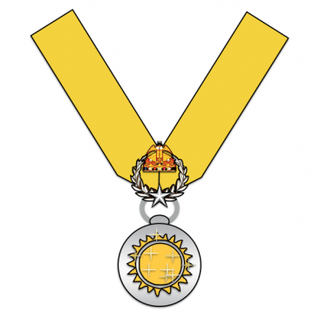
SEH
Imperial Navy

SEH
Imperial Star Marines

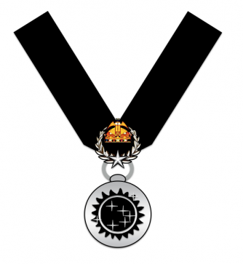
SEH
Imperial Army

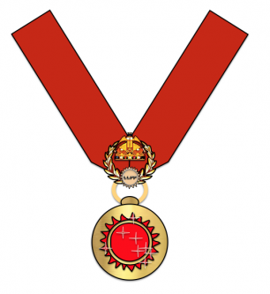
SEH
Imperial Interstellar
Scout Service

Medal for Conspicuous Gallantry

The Medal for Conspicuous Gallantry (MCG) is the Imperium's second highest valor award, ranking above the Medal for Meritorious Conduct Under Fire, but below the Starburst for Extreme Heroism. It is given for outstanding acts of bravery on the battlefield.

MCG
3rd Class

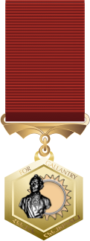
MCG
2nd Class

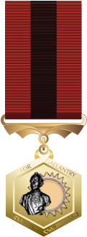
MCG
1st Class

Description
The medal is a metal hexagon suspended from a cloth ribbon. On the obverse (front) is an engraved depiction of Diirdi Khirashkur, a legendary Vilani folk hero who defeated an army through skill and trickery. On the edge are the words: "For Gallantry". On the reverse is inscribed the name of the recipient.
It comes in three classes.
Third Class is suspended from a blue cloth ribbon, and is given for the first through fifth receipts.
Second Class is suspended from a red cloth ribbon, and is given for the sixth through tenth receipts.
First Class is suspended from a red & black cloth ribbon, and is given for eleventh and additional receipts.
Additional awards are signified by a metal numeral pin worn on the ribbon to indicate the number of awards.
- The holder of an MCG ranks slightly below a Knight of the Empire in social status before the Emperor. ^{[1]}

Meritorious Conduct Under Fire
The Medal for Meritorious Conduct Under Fire (MCUF) is an Imperial decoration.
- It is the Imperium's third highest valor award, ranking above the Exemplary Service Medal, but below the Medal for Conspicuous Gallantry. It is awarded for acts of heroism or meritorious service in a combat zone.

MCUF
3rd Class

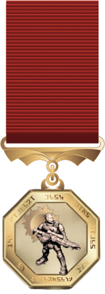
MCUF
2nd Class

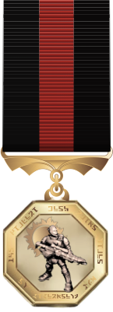
MCUF
1st Class

Description
The medal is an octagonal piece of metal suspended from a cloth ribbon. On the obverse (front) is the depiction of a resolute soldier standing his ground and motioning for others behind him to move forward and follow him. Around the edge is engraved the words: "With Great Merit and Dedication to the Service". On the reverse is the name of the recipient.
It comes in three classes.
Third Class is suspended from a blue cloth ribbon and is given for the first through fifth receipts.
Second Class is suspended from a red cloth ribbon and is given for the sixth through tenth receipts.
First Class is suspended from a red & black cloth ribbon and is given for eleventh and additional receipts.
Additional awards are signified by a metal numeral pin worn on the ribbon to indicate the number of awards.

Order of the Emperor's Seal
[OES]
The Emperor may invest a recipient with membership within The Order of the Emperor's Seal at his discretion, as recognition for exceptional dedication, loyalty, ability, and the application of those traits. This is one of the few civilian (non-military) medals that the Imperial Government can award. This is a one-time award.

Imperial Cross
[IC]
[ICx2]
The Imperial Cross is presented to an Imperial who has distinguished themselves by showing extraordinary heroism to ensure the safety and security of the Imperium. The act or acts of heroism must have been so notable and have involved risk of life or serious injury as to set the individual apart from their comrades.

Distinguished Service Medal
[DSM]
[DSMx2]
The Imperial Distinguished Service Medal is awarded to an Imperial in recognition of exceptionally long and/or meritorious service to the Emperor and the Imperium.

Imperial Gold Star
[IGS]
[IGSx2]
The recipient of this medal shall have undertaken actions involving the utmost loyalty and dedication in the finest traditions of the Imperium. The service and honour of the recipient has been recommended well above that required for an Imperial Silver Star.

Imperial Silver Star
[ISS]
[ISSx2]
The recipient of this medal shall have undertaken actions involving extreme loyalty and dedication in the finest traditions of the Imperium. The service and honour of the recipient has been recommended well above that required for an Imperial Bronze Star.

Imperial Bronze Star
[IBS]
[IBSx2]
The recipient of this medal shall have undertaken actions involving major loyalty and dedication in the finest traditions of the Imperium.

Obsidian Crescent
[OBC]
[OBCx2]
This award is presented to any member of the Imperium that has been seriously wounded (permanent disability) or killed, or who has died or may hereafter die after being wounded whilst on active duty. Individuals are not recommended for the decoration; rather they are entitled to it upon meeting the above criteria.

Purple Heart
This award is similar to the Obsidian Crescent. It is awarded for any injuries suffered whilst on active duty, and may be awarded more than once (each subsequent awarding adds a small star).

Medal of Merit
[MOM]
[MOMx2]
The recipient of this medal shall have demonstrated a superior ability to contribute to the good of the Imperium above and beyond the call of duty.

Imperial Intelligence Cross
[IIC]
[IICx2]
This award shall be presented to Imperials that have performed consistent service above and beyond the call of duty, and have personally through their action, made lasting improvements to the capabilities, effectiveness and efficiency of Imperial Intelligence as a whole.

Navy Cross
[NC]
[NCx2]
This award shall be presented to Imperials that have performed consistent service above and beyond the call of duty, and have personally through their action, made lasting improvements to the capabilities, effectiveness and efficiency of the Imperial Navy as a whole.

Army Cross
[AC]
[ACx2]
This award shall be presented to Imperials that have performed consistent service above and beyond the call of duty, and have personally through their action, made lasting improvements to the capabilities, effectiveness and efficiency of the Imperial Army as a whole.

Marines Cross
[GC]
[GCx2]
This award shall be presented to Imperials that have performed consistent service above and beyond the call of duty, and have personally through their action, made lasting improvements to the capabilities, effectiveness and efficiency of the Imperial Marines as a whole.

Scouts Cross
[MC]
[MCx2]
This award shall be presented to Imperials that have performed consistent service above and beyond the call of duty, and have personally through their action, made lasting improvements to the capabilities, effectiveness and efficiency of the Imperial Scout Service as a whole.

Achievement Medal
[ACH]
[ACHx2]
This medal and ribbon shall be presented to an Imperial whose performance, in the belief of an appropriate member of Imperial High Commands, has been exemplary and makes the recipient an asset and example for their respective branch.

Imperial Intelligence Medal of Progress
[IIMP]
[IIMPx2]
This award shall be presented for a meritorious and lasting contribution to Imperial Intelligence. This contribution should help improve current standards for Imperial Intelligence as a whole and increase the capacity or efficiency of achieving Imperial Intelligence's objectives.

Naval Medal of Progress
[NMP]
[NMPx2]
This award shall be presented for a meritorious and lasting contribution to the Imperial Navy. This contribution should help improve current standards for the Imperial Navy as a whole and increase the capacity or efficiency of achieving the Navy's objectives.

Army Medal of Progress
[AMP]
[AMPx2]
This award shall be presented for a meritorious and lasting contribution to the Imperial Army. This contribution should help improve current standards for the Imperial Army as a whole and increase the capacity or efficiency of achieving the Army's objectives.

Marines Medal of Progress
[GMP]
[GMPx2]
This award shall be presented for a meritorious and lasting contribution to the Imperial Marines. This contribution should help improve current standards for the Imperial Marines as a whole, and increase the capacity or efficiency of achieving the Marines’ objectives.

Scouts Medal of Progress
[MMP]
[MMPx2]
This award shall be presented for a meritorious and lasting contribution to the Imperial Scout Service. This contribution should help improve current standards for the scout Service as a whole, and increase the capacity or efficiency of achieving the Scout's objectives.

Imperial Active Service Medal
[IASM]
[IASMx2]
This award shall be presented to an Imperial that has seen active service in an Imperial Campaign. A clasp is awarded for each Campaign individually upon review and approval by regional Command.

Operational Success Award
[OSA]
[OSAx2]
Awarded to Imperial Intelligence Agents or Imperial Special Operations personnel who have successfully completed a Special Operation under the direction of the Bureau of Operations. Military personnel assigned to Special Operations Command may wear this award upon presentation, however only public or retired members of Imperial Intelligence may display this award.

Unit Distinguished Service
[UDS]
[UDSx2]
This award shall be presented to an Imperial Unit for excellent performance and military merits during manoeuvres. This award is one for service decidedly above that needed for a Letter of Commendation or Exercise Achievement Medal.

Departmental Distinguished Service
[DDS]
[DDSx2]
This award shall be presented to a civilian component of the Imperium for excellent performance and results during operations or a project. This award is one for service decidedly above that needed for a Letter of Commendation.

Battle Efficiency Medal
[BEM]
This award shall be granted to the members of an Imperial Unit that demonstrated conspicuous skill and effectiveness in a combat situation. This is a one-time award.

Exercise Achievement Medal
[EAM]
[EAMx2]
This award shall be presented to an Imperial whose outstanding performance in a training exercise led them to win the exercise, displaying good initiative and leadership, and being an example for their comrades of how an Imperial should fight.

Good Conduct Award
[GCA]
[GCAx2]
The recipient of this award shall demonstrate honourable behavior consistently beyond that expected of personnel in the Imperium.

Certified Imperial Security Agent
[CISA]
This medal is presented to Interstellar Bureau of Internal Security officers after their time of apprenticeship, recognising their promotion to full powers, and establishment as a Certified Imperial Security Agent.

Group Command Medal
[GCM]
[GCM-H]
This award is granted to an Imperial Officer who has completed the Naval Group Command specialisation at the Command College. This award can also be granted to a GCO who has completed a minimum of 6 months service as a GCO. Honours graduates are indicated with an oakleaf device.

Brigade Command Medal
[BCM]
[BCM-H]
This award is granted to an Imperial Officer who has completed the Marine or Army Brigade Command specialisation at the Command College. This award can also be granted to a BCO who has completed a minimum of 6 months service as a BCO. Honours graduates are indicated with an oakleaf device.

Government Administration Medal
[GAM]
[GAM-H]
This award is granted to an Imperial Officer who has completed the Regional Government Administration specialisation. This award can also be granted to an Imperial who has completed a minimum of 6 months service in the role of an Imperial Diplomat, and gained a positive review by the Diplomatic Corps. Honours graduates are indicated with an oakleaf device.

Project Management Medal
[PMM]
[PMM-H]
This civilian award is granted to an employee who has completed a minimum of 6 months service as a Project Manager for a sanctioned Imperial research project, and gained a positive review by the appropriate senior management.

Tactical Essay Contest
[TEC]
[TECx2]
This award is presented to the winner of a Tactical Essay Contest. This contest is designed to measure the abilities of the participants to solve different adverse situations with limited resources.

Imperial Literacy Contest
[ILC]
[ILCx2]
The recipient of this civilian award shall have written the best discourse in an Imperial Literacy Contest, demonstrating a high-level ability with literacy and storytelling.

Imperial Literacy Award
[ILA]
[ILAx2]
This civilian award is presented to those members of the Imperium who have contributed significantly to Imperial Literature and Culture.

Letter of Commendation
[LOC]
[LOCx2]
The recipient of this civilian ribbon shall have received one Letter of Commendation for exemplary conduct in the service of the Imperium.

Imperial Activity Medal
[IAM]
[IAMx2]
The recipient of this medal shall demonstrate activity and commitment to their duties surpassing the normal performance of their peers.

Imperial Service Medal
[ISM]
[ISM-1]
The Imperial Service Medal denotes the time of service for an Imperial member. The medal is awarded automatically after 1 year of appropriate service within any Imperial military branch.

Corporate Service Medal
[CSM]
[CSM-1]
The Corporate Service Medal denotes time of service for an civilian employee within a department or company that has been performing work for or on behalf of the Imperium or one of its agencies.

Imperial Intelligence Service Award
[IISA]
[IISA-1]
This award is presented by the Director of Imperial Intelligence to a member of Imperial Intelligence or an Agent who has actively served for a specified period of time, typically 4 years (1 term). Military personnel assigned to Special Operations Command are not entitled to this award, and only public or retired members of Imperial Intelligence may display this award.

Imperial Recruitment Medal
[IRM]
[IRMx2]
This one-time award is issued by the Imperial Centre for Recruitment, to ICR staff who have demonstrated dedication, reliability, and proven success in the field of recruitment.

Imperial Medical Department
[IMD]
[IMDx2]
This one-time award is issued by the Imperial Medical Department, to IMD staff who have demonstrated reliability and proven success in the field of medicine that has contributed to the saving of lives.

Imperial Campaign Medal
[ICM]
[ICMx2]
The Imperial Campaign Medals are is issued by proclamation of the appropriate branch Commands to all who have served in a sanctioned military campaign. The colors/stripes for these medals vary widely, and there are literally dozens available every generation.

Imperial Academy Basic Graduate
[IABG]
[IABG-H]
This award is granted by the Commandant of the Imperial Academy (Navy, Army, and Marines) for a student that has graduated at the end of their training, showing dedication and great skills. Those graduating with Honours shall wear an oakleaf device indicating their achievement.

Imperial Citizenship Award
[ICA]
This civilian award shall be presented to a Citizen of the Imperium for his contribution to the well-being of the Imperium by means of a donation of a significant amount of resources or assets. This is a one-time award.

