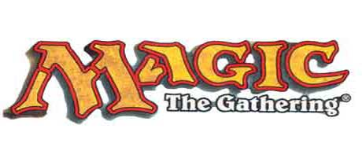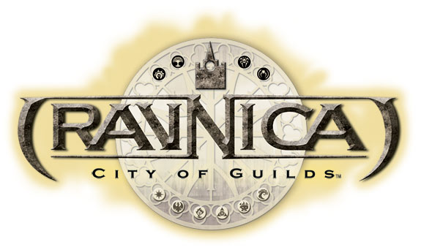You are a citizen of the great city of Ravnica. At the beginning of the game you are a member of one of the nine great guilds serving the guildpact.

Table of Contents
GAME BACKGROUND 2
THE GAME SYSTEM 2
CHARACTER CREATION 2
Introduction 2
Character Concept 3
Character Guild 3
Allowed Guild Associations 3
Guild Overviews 4
Character Background 11
Character Races 12
Human 12
Vedalken 12
Goblin 13
Viashino 13
Devkarin Elf 14
Silhana Elf 14
Simic Elf 15
Half Elf 15
Loxodon 16
Ogre 16
Minotaur (Ordruun or Izzet) 17
Centaur 17
Zombie 18
Thrull 18
Half Demon 19
The Cult of Rakdos 19
Gruul 20
Izzet League 20
Boros Legion 20
Azorius Senate 20
Orzhov Syndicate 20
Selesnyan Conclave 20
Simic Combine 20
Golgari 21
Names 21
Attributes 21
Primary Mana Color 21
Secondary Mana Color 21
The Wizard’s Talisman 22
Skills 22
Skill Descriptions 22
New Skills 23
Sanctuary 23
FEATS 23
Secret Feats 23
Guild Specific Feats 28
Starting Bonus Points 30
Cards, Shuffling and Nomenclature 30
Spell Acquisition and Ownership 31

GAME BACKGROUND
This version of the Magic the Gathering (MtG) Role Playing Game is a game focusing on the lives and exploits of wizards.

While this game can take place in any setting within the Magic the Gathering universe, from Arabian Knights card release up to the most recent edition, this version will be set in Ravnica, the City of Guilds. Rules described here are specific to this setting and may not apply to others. See the basic rules as a for anything not covered here.

THE GAME SYSTEM
The game system provides a structure by which matters of chance and action are resolved. These rules are quite simple and based on the MtG dueling rules with some exceptions and expansions in order to make a seamless joint between a Role-Playing and CCG based game. This material is not intended to be a comprehensive game or rulebook. Its purpose is to explain exceptions and references on how to make the MtG CCG a RPG experience. Other game sources and materials will be referenced in order to limit the amount of redundant explanations.

CHARACTER CREATION
Character wizards in the Ravnica MtG RPG can be of many races from any of nine guilds. Use the following steps in order to create your character.

Introduction
Ravnica is a massive city that covers an entire planet. It is a multi-layered mass of cities as well, with one district built right over others, either by building the new district on pillars and platforms above the last, or by simply pouring a new foundation over the last one and burying it completely. In the 10,057 years of the Guildpact, Ravnica has become a city that appears to be just as tall (or deep) as it is wide. There are several “undercities” in the capital, probably all over the planet, and even the Golgari aren’t sure how far down one can really go. And nobody knows what might be found down there.

Ravnica does have an official city limit, despite the fact that when you leave the city you would like notice no difference. The city itself is mostly divided into districts, and those districts are usually controlled by one of the cities nine guilds. The city center is the only know place where the original ground of the planet can still be seen, and therefore no walkways are allowed to pass between it and the sky, and no digging is allowed beneath it. Each of the nine guilds has been given a section of the hub to use as their guild hall. Most of the player characters, however, have never been inside the city center or their guild’s main hall, but all have seen the center at one point in their lives.

Player characters will be starting in Ravnica itself, though they can have originated anyplace they wish. You may invent just about any place that you need, just keep in mind the nature of Ravnica. There are “wild” places where blowing sands have re-covered huge sections of the city and they look a lot like more standard landscapes, at least from afar. Up close you can see places where crumbled buildings or rusted contraptions like water pumps and other such things poke up through the earth. But even places like these will be built over again rather rapidly, and so those that remain relatively clear of building usually are that way for a reason. For example there is a place called Utvara near the city that is a wasteland like this and only remains so because of a deadly plague that remains there. Utvara is undergoing recovery at this time and is expected to be habitable within the year.

It is into this world that your characters were born. You are native and relatively comfortable with the way the world is. You understand that there are guilds and that they rule the world and compete with each other for control of more of it than they currently have. You know that you are lucky to be in a guild, for those without the protection of a guild are effectively non-citizens, often not treated any better than animals, often worse. Many different sentient species exist on Ravnica, and few are discriminated against for their race (though that doesn’t mean that they don’t take advantage of the general natures of each race).

The guilds of Ravnica are bound by the power of the Guildpact, a document that the Parun of each guild signed more than 10,000 years ago. But this has never really stopped guilds from trying to take over. During the recent decamillenial celebration the Golgari, lead by Savra, attacked the Selesnya as they gathered around the Vitar Yescu to perform their great convocation. It took 20 years for the city to rebuild and recover.

Character Concept
Begin the character creation process by formulating a basic concept for your wizard. You don’t need to know all the details of the character at this point; just some general ideas and feelings about what sort of person the character is and where he or she comes from. You can add specifics later in the process. In general, there are two primary methods for creating the initial character concept.

The first method is to choose a concept and then build the attributes, chose skills and guild to reflect their personality. The second method is to tailor the wizard’s personality based on the guild you chose. Both are equally valid; it all depends on the desire and goals of the player.

Once you have a general idea of your character’s personality and background before joining the guild, you will work with your GM to create a more detailed description of your character’s time in the guild and most recent history.

Character Guild
There are nine guilds available for players, and each must chose a different guild. At some point before the game begins the players will have to come to an agreement by some method which will be members of what guild.

Allowed Guild Associations

- Azorius Senate
- Boros Legion
- Golgari
- Izzit
- Orzhov Syndicate
- The Cult of Rakdos
- Selesnyan Conclave
- Simic Combine
- Gruul

It is probably obvious to the players that there are ten guilds possible if each is a combination of two of the five colors. Your characters may also be assumed to be able to figure this out, but as of the start of the game most characters will know nothing more than that. Players will have to decide among themselves which character belongs to which guild. There won’t be two characters in the same guild.

Players will be have a lot of flexibility about their relationship to their guild. Black sheep, trusted member, junior member or high ranking, that’s up to you, and the cards in your library (which I will discuss with each player once their library is determined).

The descriptions below reflect opinions of opposing guilds (and, in many ways, the truth). They have a negative tinge to them because they expose the bad side of the guild. Player characters can choose to be in step with their guild or disgruntled, as noted above.

Terminology notes: Ravnica is the world-spanning city that is the setting for this game. The Guildpact is both the agreement that holds the seven guilds together in relative peace and the physical body of guild leaders and dedicated beings that uphold those rules. The Guildpact is technically overseer to the guilds and their activities, but their agents are rarely seen (or perhaps just rarely recognized as such) and the player characters have likely never seen one, nor have much of an idea what sort of beings those agents might be until the game actually starts.

Along with the brief descriptions below are two pictures. One is a representative image from guild specific cards to give you an idea about the style of each guild. The other is the guild’s symbol.

Guild Overviews

The Azorius Senate

Cold and calculating, they create the laws in Ravnica. Their bureaucracy is designed to keep the status quo as strong as possible. Its leader, Grand Arbiter Augustin, believes that change only brings chaos and trouble. In his arrogance, he has decided that the best way to serve Ravnica is to keep everyone else from acting in any way, shape, or form. Unfortunately, the Azorius have the magic and muscle to back it up.

The Azorius Senate is often underestimated by both average citizens and the other guilds. After all, all they do is make the laws, which, despite the best efforts of the Boros Legion, are often ignored. And everyone knows that the Azorius are most interested in keeping the status quo.

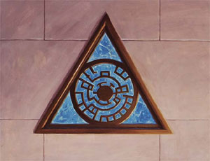
Guild Colors are Blue and White
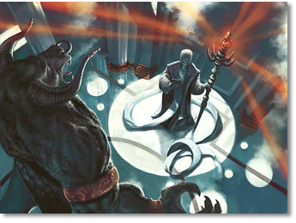

The Boros Legion

If the Azorius are the lawmakers of Ravnica, then the Boros Legion are the law's enforcers. They are supposed to keep order and uphold the laws made by both the Guildpact and Azorius. In practice, though, they tend to enforce whatever laws they feel like enforcing, not to mention a few that don't exist, except in their own hearts and minds. The Wojek, a special division of the Boros, are the main foot soldiers in this cause; every district has a permanent garrison of Wojek to protect it. The archangel Razia sends the rest of her massive forces to wherever she deems it necessary – and of course, her standards may differ greatly from that of the locals.

The Boros are all about controlled rage. Their soldiers, which include humans, goblins, and Ordruun minotaurs, are so determined to keep the peace that they will apply any warlike means they deem necessary. They tend to swing swords first and ask questions later, since they're almost always sure that whatever action they take to keep order is right. Those who oppose them, by definition, must then be wrong at best, criminal at worst.

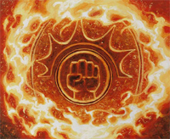
Guild Colors are Red and White
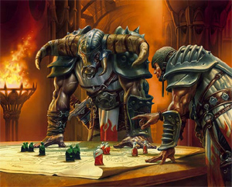

The Golgari

The Golgari preach that death is part of the natural cycle, which seems like a harmless and logical belief. However, they take it one step further, actually embracing death, and encouraging it to enhance and strengthen life. So their guildmaster, the elvish shaman Savra, doesn't mind letting loose virulent plagues. After all, all they're doing is speeding up the natural cycle so that Ravnica can be reborn after death into something better. It's not so much death itself that they like, but the rebuilding that comes afterwards.

Of course, Golgari necromancy is some of the most potent ever seen. They don't even believe that their creations are anything hideous or unnatural. Their favored pets are not only undead, but natural forces of death and decay, like fungi, insects, and saprolings. And they have a lot to work with, for Ravnica is teeming with ghosts and zombies in unusual numbers. Whether that's the Golgari's doing is something they never divulge.

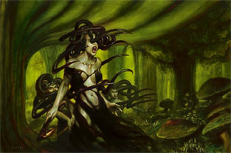
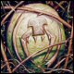
Guild Colors are Green and Black

The Izzet

The Izzet are seekers of knowledge, but their methods may be best described as "unorthodox." They pursue their research with reckless abandon, often taking on too much at once, quickly discarding old ideas for bright shiny ones that suddenly get their attention. Though they're responsible for most of the beneficial civic works on Ravnica, their behavior has also led to some spectacular and destructive failures. This reflects the personality of their guildmaster, the brilliant, but short-tempered, dragon wizard Niv-Mizzet.

The Izzet are responsible for most of the civic works that keep Ravnica going. They designed the sewers, built the foundries, and stocked the markets with every necessity and every luxury. They are tinkerers and researchers at heart, never satisfied, always working towards a bigger device or better sorcery. In fact, they're the only ones who understand how and why magic itself functions, knowledge that led to their “planar universes” theory, and speculation on how it's affected life and death on Ravnica. The Izzet are intensely focused on their work, making them the guild least interested in Ravnica's politics and daily intrigue.

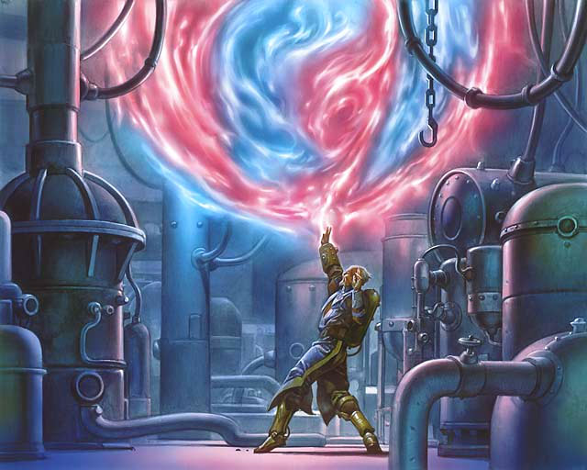
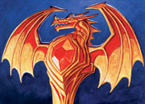
Guild Colors are Blue and Red.

The Orzhov Syndicate

The Orzhov Syndicate once followed a genuine religion, but these days, their gods are power and wealth. They only keep up vestiges of their old faith because of the entrenched power structure, not to mention the control it gives them over the masses. The Orzhov thrive on business, the buying and selling of everything from spells to land to slaves. They founded the Moon Market, a shadowy bazaar where literally anything can be bought for the right price. Thanks to their skill at deals, not to mention a well-placed bribe or three, Orzhov influence is felt everywhere, from the highest Azorius court to the lowest street gutter.

Their servitors include animated gargoyles and thrulls, which are created from corpses, often the dead bodies of lesser Orzhov leaders. When the most wealthy and powerful Orzhov die, complex necromantic rites resurrect them as ghosts, unbound by whatever dark forces limit the common shade. Thus the Ghost Council holds only the greediest, sneakiest, most intelligent minds, dating back from the founding of the guild. Their centuries of experience, along with their legions of lawyers, have made the Orzhov the most adept guild at twisting the Guildpact to their advantage. Though they may lack in martial might, they more than make up for it in wealth and cunning.

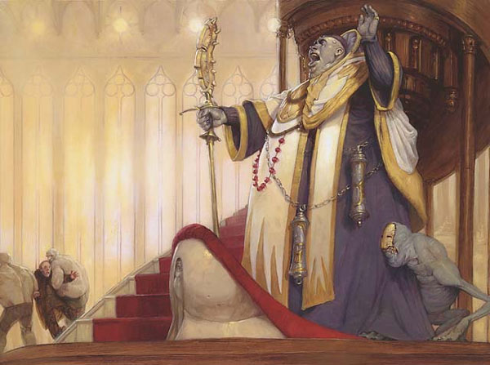
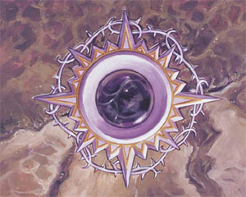
Guild Colors are Black and White.

The Cult of Rakdos

The Cult of Rakdos is named after its demon leader, Rakdos the Defiler. They are completely self-absorbed, out only for a good time. However, their idea of a "good time" usually involves murder and mayhem – the more bloody and depraved, the better. The cult would love to rule Ravnica and turn it into one big slaughter-fest, but to them, it's the process of random death and destruction that is fulfilling, not the goal. Unfortunately for the rest of the world, their idea of a party tends to involve blood, fires, and lots of screaming. If there's a way to make death more painful, or explosions more hazardous, it's certain that a Rakdos cultist is cheerfully using lots of trial and error to find it. Fortunately for the Rakdos, their interest in the dark art of death has made them into top-notch mercenaries and assassins, which the other guilds are more than happy to take advantage of. Thus does the Cult mix business with pleasure.

Of course, just because the Rakdos live in the "now" doesn't mean they can't plan ahead, or that they don't want anything more. Rakdos (as in the demonic founder of the guild) wants everyone on Ravnica to share his philosophy. As it turns out, that philosophy also creates the ideal method to spread itself! Surely, once everyone sees what a good time you can have following Rakdos, they'll follow suit… or become part of the evening's entertainment. To accommodate their needs, the Rakdos are always on the lookout for new toys during their raids: caustic liquids, torture devices, exotic beasts thought long dead… If it can kill, it makes for a great time.

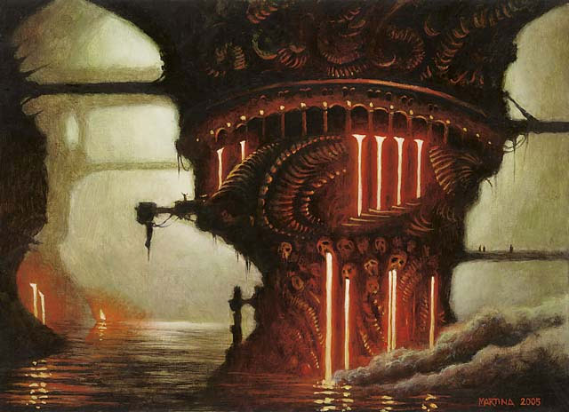
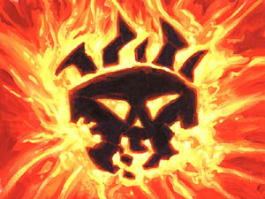
Guild Colors are Red and Black

The Selesnyan Conclave

The Selesnyan Conclave is best described as a nature-lover's commune, though one populated with gigantic beasts and powerful druids in the hundreds of thousands. Their way of life is a simple one, based on harmony with each other and (what's left of) nature, and they do whatever they can to spread this message across the globe. Directed by the Chorus, a group of ancient dryads, Selesnyans make it their mission in life to sow the seeds of their beliefs wherever they can. However, this also involves defending these seeds wherever they take root, the main reason why they have conflicts with the other guilds.

Though they may seem to be all sweetness and light, a deeper look suggests otherwise. Some citizens think the Conclave is as much of a cult as a guild, and they may not be all that wrong. Every member is a fanatic to the cause, and conformity is not demanded - it's expected as a matter of course. No one is sure whether the Conclave actually brainwashes anyone or not, but many members certainly act like they do.

Guild Colors are Green and White.
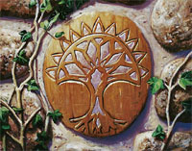
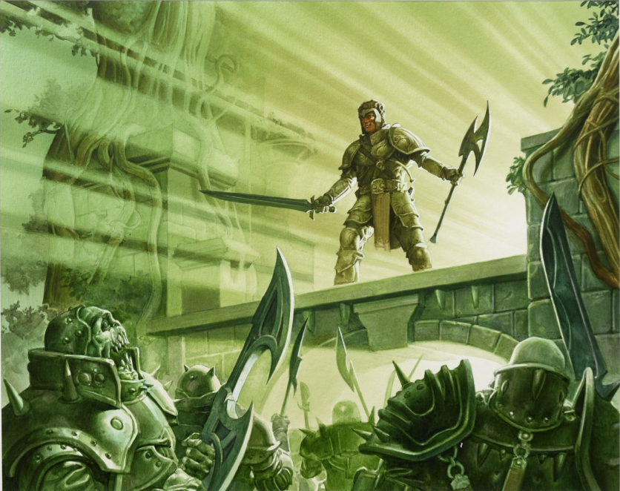

The Simic Combine

The Simic Combine is known for their scientific achievements. When the Guildpact was first put into place, the Simic were charged with preserving nature, which was already in a death spiral. The vast population, which cared about nothing but themselves, soon made sure that the Simic failed in their original objective. But from this setback arose a new opportunity, and a new purpose: creating a new natural order to replace the one that had been taken away. This new nature would be better and stronger, able to coexist and thrive alongside the now-entrenched Ravnican civilization. Thus, every living thing, from plants to frogs to leviathans to even people, is fair game for a little biomantic manipulation.

Momir Vig, the elvish biomancer who leads the Combine, oversees all work done, and determines the general direction Simic scientists take. Though much of the Simic's work has been beneficial, in the form of medical advances and other such discoveries, it's also resulted in some pretty ugly and destructive monstrosities when a biomancer gets too carried away in his work. One of their most popular inventions is the cytoplast, a symbiotic amoeba-like organism that strengthens its host, and sometimes even grants other abilities. In fact, there are dark rumors within the Combine that Momir Vig has a very special project spun off this research - a savage, instinct-driven being, based on cytoplastic technology, which Vig believes is the ultimate lifeform. What this being is, and what Vig intends to do with his new toy, is something that only the Simic leader himself can answer.

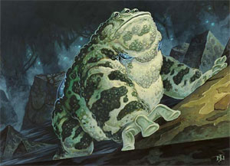
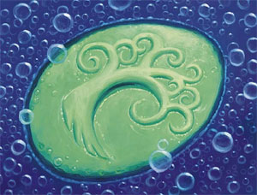
Guild Colors are Green and Blue

The Gruul Clans

The Gruul Clans celebrate base urges and live by instinct, considering all of civilization to be an elaborate cage that suppresses desire. Once a powerful guild, the Gruul are now just an assemblage of beggars, gangs, and raiding parties, with the largest of their gangs led by the cyclops Borborygmos

Before and for a short time after the signing of the Guildpact, the Gruul Clans were a wild and noble guild charged with maintaining the wild places on Ravnica. They were supposed to keep civilization in check. Civilization and the other nine guilds, however, overran every wild place on the planet. This changed the Gruul.

The Gruul decentralized, losing any sort of real leadership. Now the guild is nothing but a loose affiliation of clans and they are angry. They have been exploited and ignored and they've had enough. They take any reason to cause chaos, any reason to destroy a symbol of civilization.
It is common for Gruul clans to raid an area, destroy it, and live there until the resources gleaned from the destructive raid are used up. Once that happens, they move on to a new area, leaving smoldering ruins in their wake.

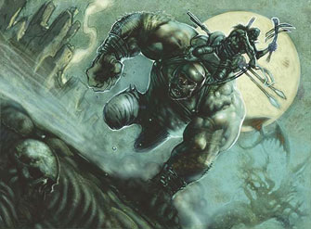
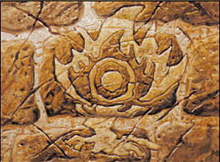
The guild colors are red and green.

Character Background
In order to create a comprehensive character history, each player needs to develop a character background based on the following:

- Each character is a member of one of the guilds of Ravnica, of which there are nine. No two characters may be of the same guild. We will find some fair and equitable way to decide who gets to pick which guild, probably by rolling dice.
- The Cult of Rakdos – nicknamed by many as the thrill-killers, for good reason. They have made a place for themselves in the city as sell-swords and hired muscle. Their guild colors are red and black and their guild leader is the great demon Rakdos, known as the Defiler.
- Gruul – wildlings and barbarians, they primarily live in the least civilized areas and rarely come into the city. Their guild colors are red and green. Their guild has no leader and is broken up into many individual tribes.
- Izzet – known for their magical experimentations and tendency to make things explode, often accidentally. Instrumental in city works. Their guild colors are red and blue. Their guild leader is Niv-Mizzet, the Firemind, one of the few remaining dragons on Ravnica.
- Boros Legion – the law keepers of Ravnica. They are agents of the laws created by the senate and range from simple street cops to flying air force. Their guild colors are red and white. Their guild leader is Razia, Boros Archangel, the leader of the angels.
- Azorius Senate – interpreters of the laws set forth in the Guildpact. They are the bureaucracy that keeps the city running. Their guild colors are blue and white. Their guild leader is Grand Arbiter Augustin, the final arbiter of all law.
- Orzhov Syndicate – the fact that their guildhall is called the Church of Deals should indicate much about them. They are the merchants guild, but they also have some of the greatest lawmages among their members. Their guild colors are white and black. They are lead by the Ghost Council, a group of powerful ghosts of the greatest of guild members.
- Selesnyan Conclave – a commune of great druids, elves and beasts. Their heart is the great tree the Vitar Yescu. Their guild colors are white and green They are lead by the Chorus, a group of ancient dryads.
- Simic Combine – the combine is a group of like-minded scientists (magical scientists) that believe that the only way to preserve nature is to improve it with their science. Their guild colors are green and blue. Their guild leader is Momir Vig, an elvish biomancer of great power.
- Golgari – this guild believes that death is a necessary part of the cycle of life. Many of the undead roaming the undercity are members of the Golgari. The guild’s colors are black and green. The guild leader is Jarad, Devakin leader and brother of Savra, who was guild leader and was killed during the uprising of the decamillenial.
- Magic is common in Ravnica. Though common citizens can’t use it, the guilds are filled with people that have some magical power or another. Most of those dedicate themselves to learning how to do one thing or a few things.
- Your character has been a member of a guild for as long or short of a time as you desire. However, at the time the game starts your character is still a guild apprentice. You have been unable to become a guild mage for some reason which you must decide. It could simply be that you have only been in the guild for a short time (it takes years to earn enough respect, even if you have the skills), or because someone above you in the hierarchy hates you. Anything at all, but you must include why in your character description.
- Your character can be of any age at all.
- Once you choose your guild, you may be of any of the races associated with that guild. You may also be of any other race if you choose, but understand that being, say, an elf that is a member of the Gruul will take some extra explaining and would be unusual and will likely cause your character some issues during the game.
- Does the character have any living relatives? Where do they live? When was the last time they were seen / visited?
- Does the character have any friends or are they a loner? Where do their friends live? When was the last time they were visited? What does the friend do for employment?
- You need not be a nice person. In fact, many of you probably should not be or your guild might not appreciate you much.
- Your character does not know any of the other characters.
- I will require a background for each character up to joining the guild. I will be helping to fill in the story from there. We will work together to create the history of your character in the guild.
- Minor character changes will be allowed after the first 2 game sessions.

Character Races

Human
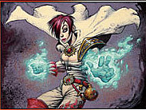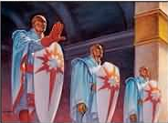
The basic, standard human. These make up a large percentage of the population of Ravnica and can be found in just about any job, guild or social status.
- Racial Mods:
  - + 2 starting skill point
    - This may bring that skill to one over the normal starting maximum

Vedalken
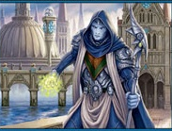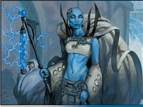
They look very much like tall humans, but with blue skin and little emotion. Though the vedalken of Ravnica are physically different from those Mirrodin (who have four arms and look dramatically less human), some Simic biomancy experiments have produced similar results, including four arms and gills.
- Racial Mods:
  - + 3 starting skill points for use only on Intelligence skills
    - This may bring that skill to one over the normal starting maximum
  - – 1 starting skill points

Goblin
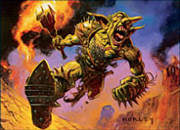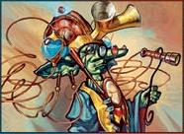
Typical goblins are small, with pointed ears, elongated noses, and green skin, though regional variations exist. Goblins tend to be impulsive, greedy, and extremely dim-witted, though there are, of course, some exceptions. Some goblins have become favorites of the Firemind for their clever approach to magic and science.

Goblins of Ravnica's Izzet guild can be extremely intelligent and eloquent, though their status is restricted by a tradition that holds that they impeded an early agenda of the guild lord Niv-Mizzet and are "owned" by the guild as a result.
- Racial Mods:
  - + 3 starting skill points for use only on Dexterity skills
    - This may bring that skill to one over the normal starting maximum
  - – 1 starting skill points

Viashino
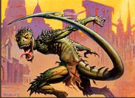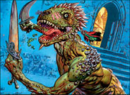
The Viashino are intelligent humanoids with lean, muscular builds. These Lizard-Folk are descended from dragons. Quick, agile, and vicious when required. On Ravnica, Viashino are not very civilized, with most belonging to either the wild Gruul Clans or the savage Cult of Rakdos, if they belong to any guild at all.
- Racial Mods:
  - + 3 starting skill points for use only on Constitution skills
    - This may bring that skill to one over the normal starting maximum
  - – 1 starting skill points

Devkarin Elf
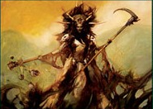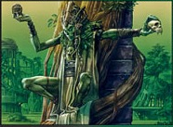
Elves are green-aligned, humanoid bipeds. Most elfish races resemble tall humans with pointed ears, though there are exceptions. Elves are only marginally stronger or faster than humans, but with a life span up to seven hundred years they normally have superior skill, knowledge and guile than any other humanoid being.

The Devkarin are essentially “dark” elves. Their skin coloration tends to be dark green running to black. They tend to have access to “black” magics and most subscribe to the Golgari beliefs in life and death. But they are not necessarily the evil beings created by D&D.
- Racial Mods:
  - + 1 skill point for use only on Wisdom skills
    - This may bring that skill to one over the normal starting maximum
  - + 1 skill point for use only on Dexterity skills
    - This may bring that skill to one over the normal starting maximum
  - + 1 skill point for use only on Constitution skills
    - This may bring that skill to one over the normal starting maximum
  - – 1 starting skill points

Silhana Elf
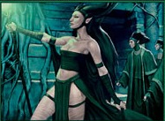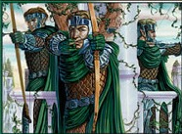
Elves are green-aligned, humanoid bipeds. Most elfish races resemble tall humans with pointed ears, though there are exceptions. Elves are only marginally stronger or faster than humans, but with a life span up to seven hundred years they normally have superior skill, knowledge and guile than any other humanoid being.

Silhana are generally light-skinned and live above ground. They are almost without fail members of the Selesnyan Conclave and are adherents to their beliefs.
- Racial Mods:
  - + 1 skill point for use only on Wisdom skills
    - This may bring that skill to one over the normal starting maximum
  - + 1 skill point for use only on Dexterity skills
    - This may bring that skill to one over the normal starting maximum
  - + 1 skill point for use only on Intelligence skills
    - This may bring that skill to one over the normal starting maximum
  - – 1 starting skill points

Simic Elf
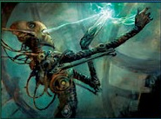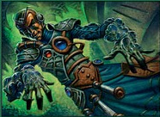
There was once a third tribe of elves on Ravnica, one that became largely extinct during the pre-Guildpact wars; the survivors joined the Simic Combine. Little is known about them, but both the Devkarin and the Silhana believe they were very cruel and unpleasant. Simic elves seem to have been mostly bald. As time went by, almost all of the Simic elves subjected themselves to strange biological experiments, adding biomechanical implants or splicing their genes with those of other creatures, such as snakes. Their skin tones vary dramatically, but are generally some shade of green.
- Racial Mods:
  - + 1 skill point for use only on Wisdom skills
    - This may bring that skill to one over the normal starting maximum
  - + 1 skill point for use only on Dexterity skills
    - This may bring that skill to one over the normal starting maximum
  - + 1 skill point for use only on Intelligence skills
    - This may bring that skill to one over the normal starting maximum
  - – 1 starting skill points

Half Elf
A human/elf half breed. They can be of any of the elf species. You know how those work.
- Racial Mods:
  - + 1 starting skill points for use only on Dexterity skills
    - This may bring that skill to one over the normal starting maximum
  - + 1 starting skill points for use only on Wisdom skills
    - This may bring that skill to one over the normal starting maximum

Loxodon
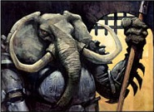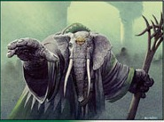
Loxodon are large humanoid elephant-folk, intelligent and highly spiritual, slow but immensely powerful. They are instinctively reclusive and are viewed as mysterious by other races, which respect them even so. On Ravnica, they traditionally belong to the life-worshipping Selesnya Conclave or the militaristic Boros Legion. In either case, Loxodon prefer to avoid confrontation and often use their intimidating size and popular respect to quell violence before it begins.
- Racial Mods:
  - + 3 starting skill points for use only on Constitution skills
    - This may bring that skill to one over the normal starting maximum
  - – 1 starting skill points

Ogre
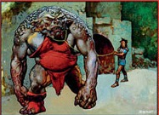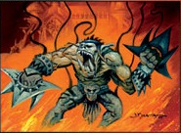
The Ogres on the city plane can actually be reasoned with, but are nonetheless slow thinkers and easy to deceive. They have a variety of appearances, though all are large and heavily muscled. They often claim association with a clan as well as their guild, though a clan in the city proper might just be an extended family, while one out in the wilds among the Gruul may be a large collection of various ogre sub-species gathered together under a strong leader.
- Racial Mods:
  - + 2 skill points for use only on Strength skills
    - This may bring that skill to one over the normal starting maximum
  - + 2 skill points for use only on Constitution skills
    - This may bring that skill to one over the normal starting maximum
  - – 2 starting skill points
  - Maximum starting skill points for Intelligence and Wisdom skills is one lower
  - Maximum starting Intelligence and Wisdom is one lower
  - Maximum starting Strength and Constitution is one higher

Minotaur (Ordruun or Izzet)
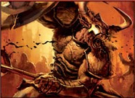
Some minotaurs were affiliated with the Izzet League, though very little is known of them. They possessed an affectation for coating their horns with Mizzium.

The Ordruun minotaurs of Ravnica have vowed allegiance to the Boros Legion and the Wojek. Orduun minotaurs perform the "Hammer Duty" and have a power band in the legion of 13. They are the peace keepers of the communities, by handling menial tasks, like domestic disturbances, transferring of prisoners, and upholding the Laws of Ravnica.
- Racial Mods:
  - + 3 starting skill points for use only on Constitution or Strength skills
    - This may bring that skill to one over the normal starting maximum
  - – 1 starting skill points
  - Maximum starting Intelligence is one lower
  - Maximum starting Strength is one higher

Centaur
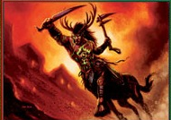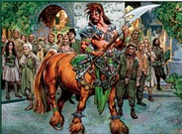
A classic mythological creature that is half horse and half human. Although Ravnica does have half elk half human centaurs with antlers in the Gruul Clan. Unlike classic Greek centaurs, Magic: The Gathering centaurs are not lust-mad lurkers nor merciless warriors. Instead, Centaurs are commonly forest keepers and druids sharing roles with Elves. Like the Greek centaurs, they are extremely fast and strong warriors and wielders of many weapons, especially bows and spears. The centaurs share a strong connection with nature and most are drawn to the Gruul Clans and the Selesnya Conclave.
- Racial Mods:
  - + 1 skill point for use only on Wisdom skills
    - This may bring that skill to one over the normal starting maximum
  - + 1 skill point for use only on Strength skills
    - This may bring that skill to one over the normal starting maximum
  - + 1 skill point for use only on Dexterity skills
    - This may bring that skill to one over the normal starting maximum
  - – 1 starting skill points

Zombie
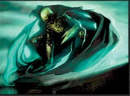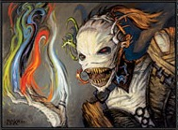
The Golgari uses ritualistic magic to make zombies, which can deliberately be made to be mindless deadwalkers for labor purposes, or letting them keep their full faculties and abilities, like their Guildmaster Svogthir, who was a zombie himself. Their zombies are usually imbued and enhanced with plants, insects or fungi.

The Rakdos, on the other hand tend to create their zombies as mindless deadwalkers and servants. Unlike the Golgari's these ones have their bodies altered with spikes, metal teeth and other torturing implants to make them more deadly. But because they are always mindless, these cannot be payer characters.
- Racial Mods:
  - + 3 skill points for use only on Constitution skills
    - This may bring that skill to one over the normal starting maximum
  - – 1 starting skill point
  - Maximum starting skill points for Intelligence, Wisdom and Dexterity skills is one lower
  - Maximum starting Intelligence, Wisdom and Charisma is one lower
  - Maximum starting Strength and Constitution is one higher

Thrull

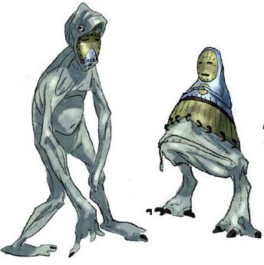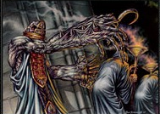
Thrulls are a signature race of the Orzhov Syndicate, who use them as unthinking servants. Orzhov thrulls are created from magically animated dead flesh - sometimes even the dead flesh of prominent guild members who left their bodies behind to become spirits. The thrulls serve multiple purposes, from gatekeepers, mortuary workers, and law-court servants to scouts, messengers, fighters, and bodyguards. Orzhov blood allows important guild members to create, communicate, or command thrulls, as well as to restore their bodies and minds after death. Some Orzhov thrulls are created using white mana. Most Orzhov thrulls sport a burnished facemask to cover their grotesque faces.

The origin of Rakdos thrulls is even more sinister and disgusting than those of the Orzhov. The Rakdos are not overly concerned with their creations' lifespan, as long as they are capable to cause sufficient damage. Unlike most other thrulls, those of the Cult of Rakdos are created using both black and red mana.
- Racial Mods:
  - + 3 skill points for use only on Constitution or Dexterity skills
    - This may bring that skill to one over the normal starting maximum
  - – 1 starting skill point
  - Maximum starting skill points for Intelligence and Wisdom skills is one lower
  - Maximum starting Intelligence and Charisma is one lower
  - Maximum starting Constitution is one higher

Half Demon
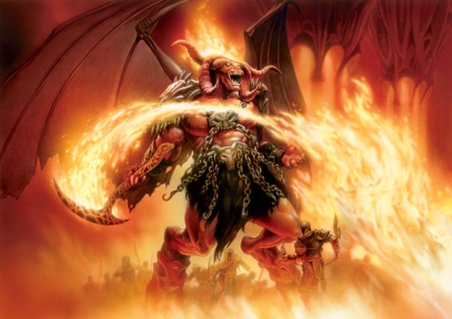
Ravnica is home to many demons, all of them quite powerful and all of them spawns of Rakdos. It is not uncommon for members of the Cult of Rakdos to offer themselves or others to such creatures for sexual purposes. Rarely such encounters result in a child, and only in the case of human-demon interactions. The half-demon can range from mostly human to mostly demon in appearance and power. For purposes of this game you may make your character look as demonic as you wish, but the power level will have to land clearly on the human side.

Demons are creatures of pure chaos and destruction. Half-demons are only slightly less so. They rarely have skill or patience for chat, discussion or debate. If something needs solving, it is best solved by crushing it.
- Racial Mods:
  - + 3 skill points for use only on Strength, Constitution or Dexterity skills
    - This may bring that skill to one over the normal starting maximum
  - – 1 starting skill point
  - Maximum starting skill points for Charisma and Wisdom skills is one lower

The following races can be chosen for characters of each guild.

The Cult of Rakdos
- Human
- Goblin
- Ogre
- Thrull
- Half Demon

Gruul
- Human
- Centaur
- Ogre
- Viashino
- Goblin

Izzet League
- Human
- Goblin
- Minotaur
- Vedalken
- Ogre

Boros Legion
- Human
- Goblin
- Minotaur
- Viashino

Azorius Senate
- Human
- Vedalken
- Loxodon

Orzhov Syndicate
- Human
- Thrull

Selesnyan Conclave
- Human
- Silhana Elf
- Centaur
- Loxodon

Simic Combine
- Human
- Simic Elf
- Vedalken

Golgari
- Devkarin Elf
- Human
- Zombie

Names
For this game you will need to pick a name for your character in the usual fashion. Ravnica is less about goofy names and more about realistic sounding names. Taking real-life names and them changing them slightly is a great way to name a character that is one of the reasonably intelligent races. Some examples of existing NPCs:
- Jarad – Devkarin Elf
- Argus – Human
- Fonn – Silhana Elf
- Teysa – Human

Also, you will be asked to come up with a cover name shortly after the game starts. So keep in mind ideas for an action-orientated nickname. For example, the person in charge of your group is calling himself Creed. Others you will be working with have names like Rock, Keen and Dredge. You don’t need this name at game start, and probably shouldn’t settle on one until you’ve played a little and gotten to know your how your character plays.

Attributes
As per the basic rules with the following exceptions

Beginning characters have twelve (12) dots to assign to their attributes when first created. There is still a Maximum of 3 dots in any one attribute for a starting character except where racial characteristics change this. At least one point must be spent on the character’s primary attribute. A wizard must have at least one dot in an attribute in order to use that attribute’s color for casting spells.

Each character will start with one dot in each of the two attributes associated with their guild. So a Simic mage would start with a dot in Dexterity and a dot in Intelligence.

Reserve Mana (Wisdom)
Reserve mana can only be used as colorless mana or mana of the characters Primary or Secondary (tertiary, etc.) mana colors.

Primary Mana Color
Each wizard chooses their primary mana source. (Record the selection on your character sheet.) This color or mana source represents the type of magic to which your Sorcerer is most closely aligned. At least half your spell deck must contain your primary mana source at all times. (See Deck Building for more information.) Please note that “colorless” is NOT an acceptable mana type.

Secondary Mana Color
At the time of creation, your character does NOT have a secondary mana color. This is something that would normally be a requirement for Guild Mage status, which your character has not yet achieved. However, you may purchase this as a starting feat (Add Mana Source) if you wish. If you chose to purchase this with your starting points, it MUST be the color of your guild. If a Golgari wizard chose green as his primary mana color, then he would have to choose black as his secondary color with starting points.

This will not be true if this feat is purchased later in the game.

NOTE: Additional mana colors are useful in this setting. They allow you to use your reserve mana for an additional color, make constructing your decks much more flexible, and make skill purchases a little cheaper.

The Wizard’s Talisman
In this campaign most talismans are made in the form a guild symbols, usually as an amulet, brooch or bracelet. In fact, your characters may never really have considered that another type might exist, though in fact they do. Hedge wizards and other unaffiliated users of magic probably use something else, though they generally can’t be found anywhere near the city.

Each Sorcerer possesses a talisman or focus that enables the wizards to cast their spells, gather mana, etc. If the wizard looses their talisman, they can make a new one in their sanctuary in a week. (Costing 100 gp). However, until the time the wizard has a new talisman, they cannot cast spells; only cantrips are possible. A talisman will detect as faint magic with the color corresponding to the primary mana type of the wizard that created it. One wizard cannot use the talisman of another; they are very personal objects that are unique to each wizard.

A new talisman can be created at any time but only one talisman can be in effect. (A backup talisman is not possible.) In addition, it’s rumored that some wizards incorporated their talisman into favorite magic items of their own creation. The exact method for doing this has been lost in antiquity.

A wizard’s spell foci and talisman cannot be the target of a spell or a grapple attempt. This is because a wizard protects their foci and talisman so well that he must be unconscious before these items can be taken from them or destroyed.

Skills
Skills are areas of expertise or learned talents. They can be anything from historic aptitude to the ability to lie effectively. A wizard’s skill level defines what they know and how well. Each skill has a linked attribute and has a maximum score of five (5) dots.

Use the general skill descriptions and use as outlined in the D&D 3rd edition rules.

A Sorcerer can have skill in something without having any dots in the corresponding attribute. The total skill level is determined by the combined dots of the attribute and the skill level (record the total on the character sheet next to the skill for ease of play).

Your wizard starts with twenty (20) skill points (dots). You must spend at least four (4) skill points in your primary skill pool as determined by your primary attribute. No skill can be greater than three (3) dots at the start of the character.

All beginning wizards automatically start with one free dot in Arcane Knowledge and Spell Research.

Having a skill in something means you can perform that skill. In most cases, if you don’t have the skill, you cannot make an attempt. However, some skills can be used untrained, such as jumping and swimming. Untrained use depends on the referee interpretation of the skill being used and the circumstance.

Skill Descriptions
All of the skills for this setting will be used as in the basic rules, excepting the following:

Other Languages (IQ) Your characters have never encountered a being in Ravnica that did not speak the Trade Tongue. All of your characters know this language. Other languages available will include a language for each guild. There are also, of course, languages for most races.

Riding (CN) In this setting wizards can ride any sort of animal. Horses do not shy away from them and are no harder to ride for a wizard than any other person. However, there may be issues based on race. A zombie will have difficulty with normal animals. A race with unusual limbs (Viashino tails, extra limbs on Simic characters), rough skin for half demons, the weight of Ogres… all of these things will matter.

Riding a familiar will give the PC a +2 to skill rolls, as the animal will try hard not to throw the character off. This is not true for standard summoned animals.

Seamanship (CH) This is NOT a useful skill in Ravnica. Though it CAN be used for piloting certain types of air ships such as specialized Zeppelids. Characters will probably not have access to such things early in the campaign, however.

Wilderness Lore (DX) This is a rare skill among most guild members. Gruul often know it, but any character may take this. In dense city areas, this skill will prove to be of little or no use. But in the few wild areas, it will be invaluable.

New Skills
Professional Skill (Varies) In Ravnica, professional skills can be very useful. An Orzhov, Boros or Azorius character might wish to know a little (or a lot) about Law. Science will probably be useful for Simic and Izzet characters. Feel free to invent others and discuss them with your GM to see what will be useful. Also, the Stat used for these skills will vary. Most will be Intelligence or Wisdom based, but they may use other stats. Again, work this out with your GM.

Sanctuary
Up until the start of the game, your character has had a space in his guild that functioned as a sanctuary. This will change very shortly after the start of the game, so don’t spend any time thinking about what that sanctuary was, unless it helps when building your character background.

FEATS
For this game variant, many of the feats have been altered. Below are those that have been changed along with those that remain the same. I’ve included both to make reference easier. I’ve also bolded changes to existing basic feats.

Some of these feats have a secondary cost in parenthesis. These are the costs of those feats when purchased with the character’s starting bonus points.

Secret Feats
Any secret feats in this campaign will be revealed as they are discovered, not before.

Add Mana Source - 12 Points (8 points)
Prerequisite: Three or more dots in the primary mana source of the caster.
This feat allows the wizard to select one additional primary mana source. Selecting this feat once would allow the wizard to use two mana-color sources as 50% of their adventuring deck. It also lowers the cost of skills in that area by one, and works in all ways like your primary mana source.

This feat can be selected multiple times until all five colors of magic have been selected. However, the requirement increases.
- The second purchase requires one more dot (4) in the primary mana source and three dots in the secondary.
- The third requires an additional dot in the primary (5) and secondary (4) sources, and three dots in the tertiary.
- The fourth requires 6 dots in the primary, 5 dots in the secondary, 4 in the tertiary and 3 in the quaternary
  - This will require some special effort, since acquiring the 6th dot in a mana source is a Secret Feat.

NOTE: If this feat is purchased with starting bonus points, it MUST be the color of the characters guild colors. So if you are a Boros wizard and you already have red as your primary, then you must choose white as your secondary if purchased with starting points. This will not be true later in the game.

Alchemy - 5 points
A wizard can create a magical potion from a spell that only effects the drinker. A potion thrown at an opponent has no effect unless the target consumes the elixir. Anybody can use a potion and gain the benefits. The spell the potion is based upon must be in the possession of the wizard and the wizard must possess a laboratory (worth at least 1,000 gp). To create a potion takes 1 day per mana point and costs 10 gp for a common spell, 25 gp for an uncommon and 50 for a rare spell per mana-point. In addition, land cards powering the potion are sacrificed as part of the needed material components. Note, any variable “X” casting costs require the use of the appropriate land card(s) in order to power the potion. (If no additional land is sacrificed, the value of the “X” is 1.) All mana has already been sacrificed at the time of creation and therefore doesn’t have to be expended at the time of the potion use.

Anybody can use a potion. The typical market value of such a potion is 50 gp + 2 times the manufacturing costs.

Alertness - 3 points
The wizard reacts more quickly in combat and therefore gains +3 to initiative. This feat can only be taken once.

Apprentice – Due to the nature of the campaign, this feat is not available

Channel Energy - 7 points
When casting a spell, a wizard can sacrifice temporary Intelligence (IQ) points to provide reserve mana. One point of IQ sacrificed yields three points of mana. The impact of the temporary loss is immediate and heals at the rate of one point per renewal period. If IQ drops to zero or less the Mage falls unconscious. Any sacrifice greater than three times the wizard’s IQ results in the wizard’s death due to the loss of all brain functions.

Charismatic Leader - 3 points
Each time this feat is taken the wizard is able to summon and control one more creature than indicated by their Charisma score. There is no limit to the number of times this feat can be chosen.

Concentration - 7 points
Gain +1 card to your hand size. There is a maximum hand size of 10 cards. Care must be taken in selecting this feat too many times prior to getting an IQ of 5 or else the previously purchased levels of concentration may be useless.

Craft Magic Item - 10 points
Prerequisite: Either Alchemy or Scribe Scrolls.
The wizard can create magic items following the guidelines noted below:
- To create a magic item, the wizard must first have the spells desired to create the magic item.
- The wizard must possess a laboratory worth at least 1,000 gp.
- Enchanting the item takes one uninterrupted week per mana-point of the spell being cast into the item (minimum one week for a zero-cost spell).
- The cost is 1,000 gp per mana-point to be enchanted (minimum 1,000 gp for zero-cost spells).
- A suitable receptacle of the highest possible quality and workmanship must be created, found or prepared. Take the standard cost of an item and multiply by 10 to get a “quality” (masterwork) item suitable for enchanting.
- The spell foci (or card) must be sacrificed as part of the material component during the creation process.
- For continuous powered items, a wizard must sacrifice permanent attribute points equal to the spells casting cost, (i.e. armor, a sword, etc.). These ability score points are lost and cannot be regained except though experience.
- For “charged” items, or items that are self powered, (i.e. a wand), the wizard must sacrifice the required land to cast the spell. Multiple daily uses of the item require more land and additional spell cards to be sacrificed. Self-powered items can only be used a number of times a day (renewal period at the same time as the creator unless otherwise specified) equal to each set of the spell cards and mana cost in order to cast the spell one time.
- Unpowered magic items cannot function without the expenditure of mana at the time of each use. Mana must be supplied at the time of “casting” the spell. However, this type of item can still only be used a limited number of times each day equal to the number of times the spell card is sacrificed at the time of construction.
- There is no DC check for checking success. Once the mana, time and money are spent, the item is created.
- Character created items can only have one enchantment. There are rumors of items having multiple enchantments, but the method for creating these types of items has been lost.

For example, suppose a red wizard wanted to make a wand of lightning-bolts. He would have to have the lightning bolt spell, spend 1,000 gp and sacrifice the lightning bolt spell card and a mountain land. Once complete, the wizard would have a wand that could shoot a Lightning Bolt once a day. By doubling the amount of gold, spell cards and Land sacrificed, the wizard could have the wand shoot Lightning Bolts twice a day. If the wizard didn’t want to sacrifice the Land, he could make the magic wand but the mana needed to power the wand would have to be supplied at the time of use. In either case, the wand could only be used a number of times each day equal to the number of spell cards sacrificed.

Now let’s suppose a green wizard wanted to make some enchanted leather armor. He would need high quality leather armor, and an appropriate spell (Carapace). After 1 week of work, the Druid would have to sacrifice the spell card, and 1 point of Dexterity (needed to power the spell). Once done, the Druid would have enchanted armor that provided 2 points of DR instead of 1. (Note, even if enchanted, a wizard cannot wear armor of any kind.)

NEW RULE – Craft Magic Item:
A wizard can make armor with an entire defensive value is based on magic. In the example above, the wizard could choose to use his magic to completely replace the structure of the armor instead of increasing the armor value. In the end that green wizard could have had magical leather armor with 1 point of DR that the wizard could actually wear. See the Armor section under Equipment for more details on requirements for wearing armor.

The typical market value of a permanent “charged” item is 5 times the manufacturing cost (wand, staff, etc) while a “continuous” item (armor, weapons, etc.) has a market value of 10 times the manufacturing cost.

Dark Vision - 3 points
Prerequisite: Low Light Vision
You can see in total darkness as a normal human does in sunlight out to a range of 60 feet.

Elemental Resistance - 5 points
Gain 1 point of damage resistance against your favored element. A wizard can only take this ability once.

Energized Cantrips - 1 point
Cast two additional cantrips a day.

Enhanced Cantrips - 1 point
Learn two additional commonly known cantrip. Unusual or unique cantrips must be researched. See spell research for more details.

Enhanced Leadership - 5 points
Enhances the Leadership feat so that the wizard increases the maximum number of experience points that can be spent by five. This feat can be taken multiple times. Each time increases the maximum by five (5) points.

Enhanced Renewal - 15 points +
A wizard choosing this feat gains an additional renewal period each day. Choose from the remaining three renewal periods (of the four: Sunrise, Noon, Sunset, Midnight) and note the additional period on the character sheet. Each successive selection of this feat costs an additional 5 points. This makes the cost as follows: 15, 20, and 25 points.

Enhanced Spell Research - 5 points
Having this ability lowers the difficulty for researching spells by one category or 3 points. A wizard may only take this feat once.

Extend Spell - 3 points
Each time this feat is taken, it adds the prime statistic score again to the duration of a spell outside of combat. For example, suppose a red wizard with a Strength score of 3 takes this feat twice. His total duration of spells outside of a duel is (3 base + 3 first feat + 3 second feat) 9 minutes.

Immortality - 25 points
Perquisite: Constitution of 5, access to a very powerful lab and someone that knows how to do the magic. Those last two need to be found in game.
The wizard no longer ages and cannot die of aging effects. The Note, this powerful and rare feat must be acquired through role-playing and approval of the referee. In most cases a major quest will have to be completed to discover the method to gain immortality

Improved Dodge - 4 points
Each time this ability is taken, the wizard gains one additional dodge maneuver that he can use in a turn. Thus, if the Wizard had 2 levels of improved dodge, the Wizard could dodge 3 creatures in a turn. All starting Wizards can dodge one creature in a round.

Increased Spell Range - 3 points
The wizard can cast spells farther than normal. This feat adds one dot to the associated attribute for determining spell casting ranges. This feat can be taken multiple times.

Leadership - 2 points +
The wizard gains a familiar. The familiar is not a wizard or summoned monster; rather a normal creature of the wizard’s choosing without any special abilities.

For 2 experience points the cohort has a total power and toughness equal to two (2), a 0/2 or 1/1 creature. If the follower dies, they are gone. A replacement will have to be purchased once again. For additional points, the follower can be augmented upon purchase or in the future:
- 1 experience point for an additional point of power or toughness up to a maximum of 5/5.
- First Strike - 3 points
- Ridable - If the creature has enough strength (Power), the wizard can ride the familiar
  - Terrestrial based creature costs 5 points. Requires a Ride role DC 5 to cast a spell.
  - Flying creatures cost 7 points. Requires a Ride role DC 6 to cast a spell while flying.
- Flying - 3 points
- Protection from one (and only one) mana type - 5 points
- Landwalk of the wizards’ choosing -5 points. Maximum of one landwalk ability. Only useable during combat.

The wizard is able to mentally give commands (but not communicate) to the familiar. Being natural creatures, they cannot be raised from the dead. A wizard can only spend a maximum of 10 experience points on a cohort.

An example of a cohort would be a 3/3 flying hippogriff that could carry the wizard while flying for 16 points.

Low Light Vision - 3 points
You can see in darkness out to 60 feet if there is a little bit of light (starlight, a torch, candle, etc.).

Lucky - 5 points
Replay a card for a previous action that had failed. You can use this feat every 3 hours of game time. Once used, the player must wait at least 3 hours before using it again. In addition, a lucky character gains a +3 bonus to all “luck” card draws. A wizard can only take this feat once.

Machine Master – Power – Due to the fact that there are very few artifact creatures in this setting, this feat would be pretty useless, so it can’t be purchased (for your own good)

Machine Master – Toughness - Due to the fact that there are very few artifact creatures in this setting, this feat would be pretty useless, so it can’t be purchased (for your own good)

Mana Extension - 2 points
Similar to the Extend Spell feat, but for mana. Each time this feat is taken, it extends the amount of time land can be retained outside a duel by the wizard’s prime attribute score. Suppose the same red wizard from our prior example (having a Strength score of 3) takes this feat twice, it would extend the duration of played land by (3 based +3 first feat +3 second feat) 9 minutes.

Mana Reserve - 7 points
Gain +1 to the wizard’s mana reserve. See the Wisdom attribute for more regarding mana reserve.

Mental Toughness - 5 points
The wizard does NOT go insane or unconscious when he runs out of spell cards. He can continue to function, but without the ability to cast any spells until the wizard’s next renewal period.

Quicken Spell - 15+
Prerequisite: Craft Magic Item.
Upon completion of a ritual which leaves a permanent arcane mark (tattoo) upon the wizard, he is able to cast a spell without the use of a spell card or even mana. During the ritual, the wizard sacrifices the spell card, 1,000 gp per mana point, and all the necessary attribute points for mana to cast the spell once (see Craft Magic Item for sacrifice logic). Essentially, the wizard is making himself a living magic item. Afterwards, the wizard can cast the spell instantly one time each spell renewal period.

The cost is 15 character points plus 1 point for each point of casting cost. This feat can be taken multiple times for the same or different spells.

Scribe Scrolls - 10 points
A wizard can create magical scrolls out of spells. Only wizards can use scrolls. The spell the scroll is based upon must be in the possession of the wizard and the wizard must possess a laboratory (worth at least 1,000 gp). To create a scroll takes 1 day per mana point and costs 25 gp for a common spell, 50 gp for an uncommon and 100 gp for a rare spell per mana point. In addition, the land cards powering the scroll must be sacrificed as part of the needed material components. Because of the sacrifices, all mana has already been expended at the time of creation and therefore doesn’t have to be supplied at the time of the scroll use. Note, any variable “X” casting costs requires the sacrifice of the appropriate land card(s) in order to power the scroll. If no additional land is sacrificed, the value of the “X” is 0. The market value of a scroll is 50 gp + 2 times the manufacturing costs. A scroll can be used to aid a wizard in researching the spell contained in the scroll. The scroll will lower the difficulty of the spell research by one category (3 points). However, the scroll is consumed during the spell research process.

Sleight of Hand - 5 points
A wizard can draw two more cards at the beginning of a duel and decide which of the three will be used for the ante card. Replace all other cards back into the deck and reshuffle. This feat can only be taken once.

Spell Acquisition - variable cost
Gain a new spell card. See the Spell Acquisition section for more details.

Spell Cooperation - 3 points
Multiple wizards can cooperate with each other to add as much mana as they have available to a single spell. Each wizard must have the spell card in their spell deck. Only one wizard must actually have the spell in hand. It’s a good way to make a really big fireball, etc. The participating wizards can hold their initiatives in order to act in the same phase. It’s rumored that this is the way powerful magic items were made.

Spell Preparation - 10 points
At the start of a duel, the wizard can choose one spell from their spell deck and put it into their hand as part of their initial draw. Choose to use this feat before any cards are drawn. Discard down to the appropriate hand size after drawing the card. Shuffle the library after selection. This will be the first card taken. This ability can only be selected once.

Toughness - 2 points
The wizard gains one (1) additional Life Point. This feat can be purchased once per point in the character’s main mana stat.

Traveling Spell Book - 7 points
The wizard can reorganize his spell deck with known spells away from his sanctuary. This process takes an hour and can occur at the wizard’s renewal period.

Weapon Specialization - 5 points
Adds +1 damage or power when using a chosen weapon, such as long sword, heavy cross-bow, short sword, staff, etc. This feat can only be taken once for any one item. Multiple uses of the feat apply to additional weapons.

Widen Spell - 10 points
This feat enables the wizard to affect one more target with a spell that normally affects only a single opponent. The wizard must pay the entire casting cost again to affect another target. This feat can be taken multiple times, each time enables the Sorcerer to affect one more opponent. Taking this feat three times allows the Mage to effect a total of 4 opponents with a single spell.

Guild Specific Feats
These feats are generally specific to guilds, but can be acquired outside of the guild with a lot of effort and roleplaying.

Also, these feats are much like the Quicken Spell feat. They are abilities that the character can use as often as they want, but it requires a use of mana and may or may not “tap” the character when used. They are the skills taught to guild mages as part of their rise to that status. Player characters have not yet reached that status at the start of the game, but could have learned these skills before the game starts.

These feats not only have prerequisites, but also costs that will need to be pain by the wizard learning the spell. If these feats are taken during character creation, it may be done before stat points are expended. This means that you may pay the stat cost for the spell from your initial attribute points before spending them. This will allow your character to start the game with max attributes in any stat.

Example:
Our example green wizard wants to purchase Regraft, the Simic guild feat during character creation. He can do so (at a cost of 1 dexterity) and then spend the 11 remaining attribute points on attributes and still have the maximum allowed dexterity if he chooses to spend his points to do so.

- Boros
  - Fury of Faith – 10 points (7 points) and 1 Strength
    - : Target creature gains haste until end of turn.
  - Faith’s Reach – 10 points (7 points) and 1 Wisdom
    - : Target creature gains first strike until end of turn.
- Selesnya
  - Burst of Life – 12 points (9 points) and 2 Dexterity
    - : Put a 1/1 green Saproling creature token onto the battlefield.
  - Faith in Life – 12 points (9 points) and 2 Wisdom
    - : Creatures you control get +1/+1 until end of turn.
- Golgari
  - Rebirth from the Loam – 13 points (10 points) and 2 Constitution
    - , Sacrifice a creature: Return target creature card from your graveyard to your hand.
  - Loamgrowth – 13 points (10 points) and 2 Dexterity
    - : Put a +1/+1 counter on target creature.
- Simic
  - Regraft – 10 points (7 points) and 1 Dexterity
    - : Move a +1/+1 counter from target creature onto another target creature with the same controller.
  - Aura Graft – 10 points (7 points) and 1 Intelligence
    - : Attach target Aura enchanting a permanent to another permanent with the same controller.
- Izzet
  - Exigent Replication – 11 points (8 points) and 1 Intelligence
    - : Copy target instant spell you control with converted mana cost 2 or less. You may choose new targets for the copy.
  - Considered Replication – 11 points (8 points) and 1 Strength
    - : Copy target sorcery spell you control with converted mana cost 2 or less. You may choose new targets for the copy.
- Rakdos
  - Weaken – 12 points (9 points) and 2 Constitution
    - , Discard a card: Target creature gets -2/-2 until end of turn.
  - Manifest Rage – 12 points (9 points) and 2 Strength
    - : Put a 2/1 red Goblin creature token with haste onto the battlefield. Exile it at the beginning of the next end step.
- Gruul
  - Eruption – 12 points (9 points) and 2 Strength
    - , Sacrifice a land: Gruul Guildmage deals 2 damage to target player.
  - Land’s Gift – 12 points (9 points) and 2 Dexterity
    - : Target creature gets +2/+2 until end of turn.
- Ohrzov
  - Ancestral Gift – 11 points (8 points) and1 Wisdom
    - : Target magic-user gains 1 life.
  - Dark Touch – 11 points (8 points) and1 Constitution
    - : Each magic-user nearby loses 1 life.
- Azorius
  - Lawful Restraint – 11 points (8 points) and1 Wisdom
    - : Tap target creature.
  - Righteous Denial – 11 points (8 points) and1 Intelligence
    - : Counter target activated ability. (Mana abilities can't be targeted.)

Starting Bonus Points
Characters in the Ravnica campaign setting will start with 18 character points that they can assign wherever they choose, within the restrictions for starting characters. These must all be spent during character creation, none may be saved. The cost for purchasing things with these points is different than spending experience.

- Attribute Increase – 4 points
  - Maximum 3
  - NOTE: You start with one dot in the two attributes related to your guild.
- Skill Increase – 2 points
  - Maximum 3
- Feats: As specified
  - Note that some feats are cheaper when purchased with these points, noted with costs in parenthesis.

EQUIPMENT
The same assumptions about basic equipment in the original rules apply in this setting.

Weapons
Weapons are the same here as in the original rules. However, ranged weapons are possible, but will need to be acquired during the game. It will be possible to attack someone with your Strength (Red) at range and affect flying creatures. However, other creatures will be able to do the same and those that can attack back will do so, just like regular ground combat.

Armor
As in the original rules, wizards generally don’t wear armor. However, they can if they are strong enough.

A wizard can wear magically enhanced armor. ALL of the defensive value of the armor must be provided by magic (see the armor making rules changes for more details). But the wizard can only have as much armor as they average of their Strength and Dexterity divided by 2 and rounded down (for the math-challenged, just add up the two stats and divide by 4, round down).

So a wizard with a strength of 3 and a dexterity of 2 could have 1 point of purely magical armor.

A wizard wearing armor that meets these requirements will be able to cast spells.

Cards, Shuffling and Nomenclature
To make things clearer, let’s set forth some names for the three piles of cards players will need to keep track of.
- The cards in your deck that is kept face down and from which you will be drawing your cards from is called the Library.
- Once you use a card as a spell you have “cast” it. Those cards are placed in a face up pile near your Library. That pile is called your Graveyard.
- Cards used for skill checks or actions are placed face up in a different pile near your library called the Discard Pile. To help keep this pile distinct from your Graveyard, it should be turned horizontally.

Cards in your graveyard are only returned to your library at a renewal period. Obviously at this time all of your cards will be shuffled together to form your complete library.
Cards in your Discard Pile should be shuffled into your library under the following conditions:
- If you have no more cards in your library, but you still have cards in your discard pile. In this case your library is not empty, simply shuffle the discard pile and make that into your new library.
- If you have four or more cards in your discard pile, then shuffle them into your library.
  - I’m adding this rule to remove the ambiguity of the original rules and to reduce the opportunity to abuse the system by shuffling good cards back into the library quickly or leaving less useful cards in the discard pile for a long time so that you don’t have to draw them again.
- At your renewal period, shuffle all cards from your hand, graveyard, library and discard pile together to create your new library.

Spell Acquisition and Ownership
In the setting of Ravnica, acquisition and ownership of some spells can have ramifications. Some spells are creations of the guilds, either handed down for years or created by the efforts of guild mages. The guilds consider these spells their secret. Practically, most guild mages just aren’t capable of casting the special spells from other guilds, as they rarely master more than two colors of magic and they always choose the colors of their guild. Even so, a non-member of the guild seen using one of these guild spells from another guild could find themselves under serious scrutiny or direct danger, depending on the guild involved.

This gets more complicated for creature spells. Such spells can only be created using a sort of magical imprint from that creature. For some creatures, such as animals, these imprints can be taken easily enough and the creature will complain very little (though the process does weaken the subject for several days). But when the essence is taken from an important figure to enhance the power of the mages of their guild, finding such a spell in unwanted hands will almost always arouse anger.

So player characters should be aware that even ownership of such spells can cause them issues in game.

These spells can be identified by simple means. They will have both colors of a guild in their casting cost. They might also have the guild’s name in the spell name. Some examples:
- Boros Recruit – obviously a Boros guild spell. Each recruit is expected to allow their imprints to be taken and used by the guild mages to craft spells. As a simple and common spell, it is unlikely that anyone would be extremely angry about finding a non-guild member with the spell. However, there would likely be questions about how the person obtained the spell.
- Azorius First-Wing (a 2/2 flying griffin) – This creature is a product of a lot of effort and training by the Azorius guild, and finding that someone had the spell made from its imprint would certainly warrant questions of legal ownership and might induce several years of legal responses.
- Momir Vig, Simic Visionary – This is a rare thing to find and obviously something that the Simic would never want to find in the hands of anyone outside the upper ranks of their guild. Momir Vig is the leader of the Simic, and even though the imprint for this spell is certainly from a while ago and his power has undoubtedly increased, if Momir Vig did not give you the right to have that spell, he would likely kill you to take it back.

Spell Research
On the same note, imprints may be required to research spells that summon creatures.

Land Acquisition
Land also requires an imprint be made in order to turn it into a spell card. Because there are several special lands in the Ravnica setting, a character must take an imprint from that place in order to make a spell card for that land.

Guilds have access to “possessed” land areas as mentioned in the original rules that they allow some of their guild members to use. Otherwise, it can be very difficult to locate a suitable location for a land source in Ravnica, as most of the surface and undercities are owned by one group or another.

