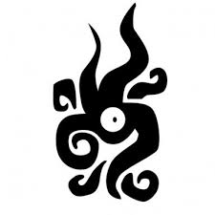 Shattered Stars |  |  | Class / Concept/Archetype
Name
 |  |  | Physical Description (Race, gender, age, attire, etc.)
Level | 1 | Start Date:
Max Life Pts |  | (10+ add Body each level)
Intimacy
Intimacy
Intimacy | (Reserved)

Attribute | Definition | Base Modifier | Associated Skills  Body Mind Charisma
Body | Toughness and Agility |  | Athletics   Stealth   Trickery  | Craft __________   Investigation   Lore – Engineering   Lore – History   Lore – Nature   Lore – Religion   Lore – Science   Medicine / Healing   Perception   Profession _____  | Deception   Handle Animal & Riding   Insight   Intimidation   Leadership   Performance   Persuasion 
Mind | Intelligence, Reason, Wisdom, and Instinct |  | Weapon Proficiencies  (1+Attack score)          
Charisma | Appearance , Social Graces, Personality and Leadership
Spirit | Luck, Mystical power, Karma
Attack | Melee or Missile
Defence | Dodging (vs missiles) and Blocking (vs melee)
Sanity | Mental Stability | 0 | Starts at 0. Goes up | Delusions:
No training needed to use “Everyman” skills but if you are untrained (no skill dot) you are at disadvantage. You cannot use a “Trained” skill unless you are trained. Skills dots – 4+IQ modifier

Abilities / Powers
1st
1st

Noted Skills & Specials

Special Equipment & Loot Carried
Special Equipment / Weapons / Tools | Loot / Cash / Jewellery / Items of Value
Melee Weapon: | Wealth Level:
Missile Weapon:
Armor & Shield:

Background

