Gideon “One-Shot” Baylord II

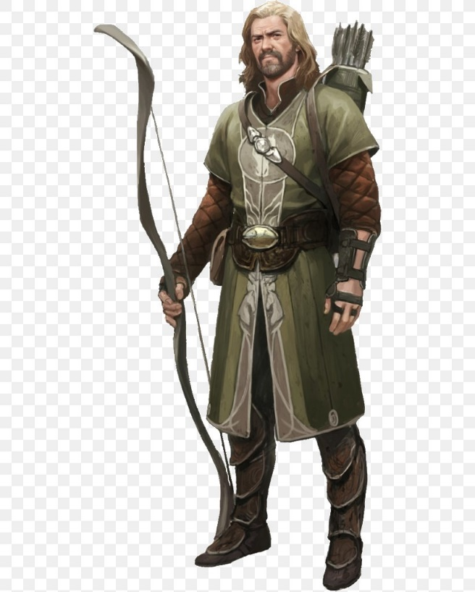
Physical Description: Human; 40; 5’10”, 175 lbs; graying hair often tied back in a pony tail; patchy mustache and beard with streaks of gray as well; wears well worn hides from animals that he hunted himself; missing the ring finger on his “pull” hand when he reached into a trap and was bitten by a badger

Family: One younger brother, Emelio, who runs his family business; younger sister, Karyn, who has with three young kids of her own; father is deceased and his mother is alive but in failing health. He sees them maybe once or twice a year when his travels take him near his old old home.

Education: As the son of a rich merchant, he was educated at home but left soon after.

Where and how do you live: He was bit by a wolf and turned into a lupine at the age of 16. The following week, he killed several kids including the young girl that he secretly hoped to marry. While the town tried to find and lynch him, his wealthy father paid a group of high-level adventurers to track, stop and cure his son. This worked but left Gideon in a severe depression once he realized what he had done. Although the town never knew he was the cause, his guilt finally forced him to leave as the memories were just too overwhelming. He left the family business to his younger brother who frankly, had a better head for business and sailed off to find adventure. His internship with a tracker started his appreciating for hunt, which he learned he had a definite knack. This led to his eventual calling as a Ranger.

Career/Job-Income: Earned most of his income hunting and tracking but eventually gained wealth and prestige working with a couple of different adventuring groups.

Hobbies: Although he hated himself for what he did as a lycanthrope, he can’t forget the intense animalistic feelings buried deep down inside. So, he eventually specialized as a Beast Master to regain some of the animal like abilities he remembered possessing. It’s a weird dichotomy – longing for the abilities that ultimately causes him such internal pain and remourse.

Faith/Religion: Is ale a religion? Nothing else specific although he doesn’t look down on those who do believe especially when he considers that it was a man of faith who cured his affliction.

Pets: He has had several hunting dogs as companions and frankly, finds them more companionable than most people. He even kept the badger that big off his finger for some time before it got uppity and ran off. Figured if it was able to get his finger before he noticed, it would be a great pet! His most recent dog, Lady, passed away of old age, and he has yet to find a suitable replacement.

Relationships: He has several associates in different towns but he has traveled too much and never made permanent friends. Some would assume it’s a lonely life, but he likes to think of it as uncomplicated and full of adventure. He has traveled with a couple of adventuring groups though and is loyal to those who he works with. He recently went home and met his 4-year-old niece for the first time. The unadulterated happiness on his sister’s face moved him, and he’s been considering finding a mate and settling down. He was considering where he would plant himself when he heard stories of Damara and an evil lych that has destroyed the nation. Figuring that he has a little more fight in him still, he figured he would go check it out and see if maybe he can find someone special along the way.

Personality: He has a hard time saying no to those in need – his way of making up for the wrongs he did as a kid. Although a part of him knows he should have made up for that years ago, he just can’t seem to stop himself. He is especially partial to helping those without the resources help themselves – either physical, mental, or financial. He is not beyond giving a good ass-kicking to those who deserve it but does firmly believe in second chances too, which often gets him in trouble with other more focused, law abiding folks.

Motivation/Drive: He strives to find peace within himself by helping the unfortunate but worries that there is a propensity for evil doing buried down deep that will one day come out.

Former Character Class: Ranger

Former Alignment: Chaotic/Good

What is your connection to Damara: It’s less about Damara and more about one last challenge to write some serious wrongs. However, when he was last home, he heard that the family of his young would-be lover (or so he had hoped before she died) had moved to Damara. Coincidence? Why the hell not? But he will see if he can track them down and save them if possible.

Other Info: Known professionally as “One Shot”. Rumer has it that he and a group of adventurers where hired by a small coastal town that was plagued by a ruthless band of pirates who would come by once a year to steal their gold, beat their women and rape their dogs (or something like that). This year, the town had enough and hired them some professionals. As the pirate ships were approached the city, the group of adventurers took one look at the armada of ships and fled (damn mercenaries). Gideon, however, pulled his bow and shot one arrow despite the fact that the lead ship was 300 yards away. Although an impossible shot, he hit the captain square in his eye, killing him instantly. As the Captain fell with his hands still clasped to the wheel, he turned his ship and rammed the next ship over sinking them both. Although there were more than enough ships and men left to sack the town, they were a superstitious lot and fled from the crazy archer. This story – along with a few more that Gideon actually made up to enhance his reputation– helped pave the way for a successful career.

Words:
Bow: never run out of normal ammo; can instantly call any ranged weapon I’ve used back to me; won’t hit my friends
Endurance: Con to 16 and don’t need to eat, sleep or drink (but there will be drinking!)
Shapeshift: Invincible defense against altering my shape including maiming/mutilation; can heal HP’s equal to level once per day

Gifts:
Omnipresent Reach (arrows are d10; range is site)
Seeking Flight (with committed effort, an enemy is AC 9 to my shots and do not have cover)
Body of Iron Will (AC 3 and invulnerable to normal environmental hazards)
Amaranth Vitality (heal 1 HP every 15 minutes)
Ten Thousand Skins (turn into a creature from mouse to moose sized)
Knack of the Borrowed Shape (can get one magical ability of the creature I turn into)

